Addis Ababa Institute of Technology School of Electrical and Computer Engineering Computer Stream

Library Management System Application Mapping and Normalization (Phase two)

**Group 8**

# Name ID Number

# 1. Nigatu paulos ……………………….ATR/7852/10

# 2. Yeshiwas Tikimu……………………...ATR/8855/10

# 3. Yosef Mesfin…………………………..ATR/3423/10

# 4. Abubeker shemsu………………….ATR/9041/10

The ER diagram

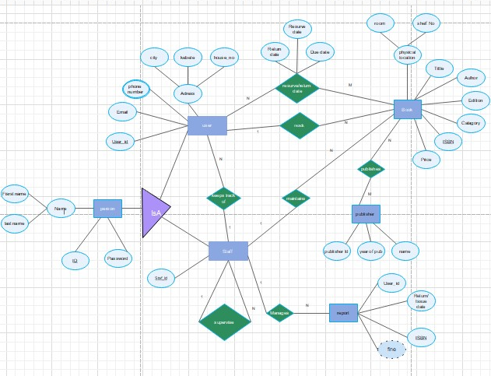

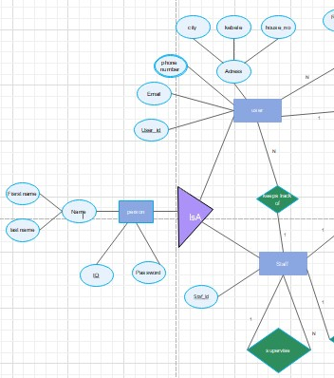

To map Generalization using Option 8A: Multiple relations-Super class and subclasses

**Person**

|  |  |  |  |
| --- | --- | --- | --- |
| Id | password | First_name | Last_name |

**User**

|  |  |  |  |  |  |
| --- | --- | --- | --- | --- | --- |
| User_Id | city | kebele | House_no | Email | keeper_StaffId |

**Staff**

|  |  |
| --- | --- |
| Staff_id | Super_id |

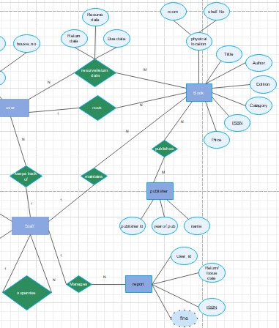

|  |  |
| --- | --- |
| Staff_id | Super_id |

**Report**

|  |  |  |  |  |
| --- | --- | --- | --- | --- |
| Reporter_id | User_id | Return_date | ISBN | fine |

**Book**

|  |  |  |  |  |  |  |  |  |  |
| --- | --- | --- | --- | --- | --- | --- | --- | --- | --- |
| Mgr_id | Title | Author | Edition | Category | ISBN | room | Shelf_no | price | Reader_id |

**Publisher**

|  |  |  |
| --- | --- | --- |
| Publisher_id | yearOfPublication | Publisher_name |

**Publishes**

|  |  |
| --- | --- |
| ISBN | Publisher_Id |

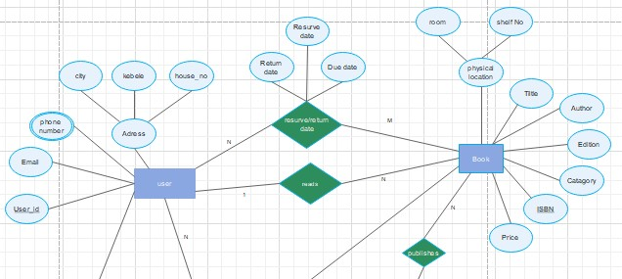

**Book**

|  |  |  |  |  |  |  |  |  |  |
| --- | --- | --- | --- | --- | --- | --- | --- | --- | --- |
| Title | Author | Edition | Category | ISBN | room | Shelf_no | price | Reader_id | Mgr_id |

**User**

|  |  |  |  |  |  |
| --- | --- | --- | --- | --- | --- |
| Email | city | kebele | House_no | User_Id | keeper_staffId |

**Reserve**

|  |  |  |  |  |
| --- | --- | --- | --- | --- |
| Reserve_date | Return_date | Due_date | Reserever_id | Reserved_ISBN |

**User_PhoneNo**

|  |  |
| --- | --- |
| User_id | User_PhoneNO |

Normalization and functional dependency of Mapped diagram

1.Book Table

* Each book have unique ISBN
* Every edition of same book have deferent ISBN
* Same title will have deferent ISBN , because of the edition

>Functional dependency

|  |  |  |  |  |  |  |  |  |  |
| --- | --- | --- | --- | --- | --- | --- | --- | --- | --- |
| **ISBN** | Title | Author | Edition | Category | room | shelf number | Price | Reader Id | mgr. ID |

>Normalized form

|  |  |  |  |
| --- | --- | --- | --- |
| **ISBN** | Title | Category | Edition |

|  |  |  |
| --- | --- | --- |
| ISBN | **shelf number** | room |

|  |  |
| --- | --- |
| **Title** | Author |

|  |  |  |  |
| --- | --- | --- | --- |
| ISBN | Price | **Reader Id** | mgr. ID |

**2.Person**

>Functional dependency

|  |  |  |  |
| --- | --- | --- | --- |
| **Id** | password | First_name | Last_name |

>Its normalized form( no need to normalize again )

**3.User**

>Functional dependency

|  |  |  |  |  |
| --- | --- | --- | --- | --- |
| **User_Id** | city | kebele | House_no | Email |

>Already normalized

**4. Staff**

**>Functional dependency**

|  |  |
| --- | --- |
| **Staff_id** | Super_id |

Its normalized form (need to normalize again)

**5.Report**

>Functional dependency

|  |  |  |  |  |
| --- | --- | --- | --- | --- |
| Reporter_id | **User_id** | Return_date | ISBN | fine |

>Normalization:

|  |  |  |
| --- | --- | --- |
| **User_id** | Return date | ISBN |

|  |  |  |
| --- | --- | --- |
| **ISBN** | Reporter_id | fine |

**6.Publisher**

>Functional dependency

|  |  |  |
| --- | --- | --- |
| **Publisher_id** | Year_Publication | Publisher_name |

>No need of normalization already normalized form

**7.Reserve**

>Functional dependency

|  |  |  |  |  |
| --- | --- | --- | --- | --- |
| Reserve_date | Return_date | Due_date | **Reserever_id** | **Reserved_ISBN** |

>Normalized form

**8.User_PhoneNo**

>Functional dependency:

|  |  |
| --- | --- |
| User_id | User_PhoneNO |

>Its normalized table no need to normalize again